DBM 360 Inquiry

University of Advancing Technology

Tyler Widener

Wearable technology is rapidly being infused into our daily lives. As the world becomes more and more reliant on technology, wearable tech is becoming more available to the common consumer. The most prevalent example of this is through various smartwatches that have been released, especially in recent years. What may come as a surprise is how long smartwatches have been around.

Smartwatches can be traced back all the way to the early 1970s. The Hamilton Pulsar and Calcron Calculator were the earliest ones, with the Pulsar released in 1972. (Lutkevich & Provazza, 2022) Computers at this point have been around for a little bit but were now starting to get to a size where they are more manageable, and able to fit in a small enough package to be worn.

Later, in 1983, the Seiko Data 2000 released. It had a nice looking digital display for it’s era, and was mostly used as a timepiece. The twist is that it came with a small keyboard that could be attached to it, meaning the watch could store two notes of up to a thousand words each! (Lutkevich & Provazza, 2022) This kind of technology so soon is an incredible step towards modern smartwatches.

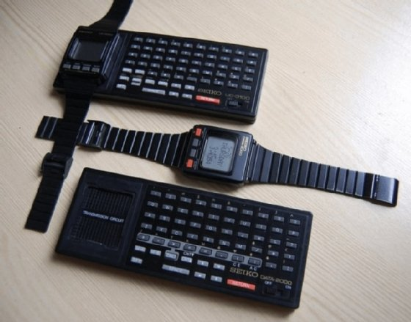

(Lutkevich & Provazza, 2022)

As the years went on, smartwatches continued to evolve, and began catering mostly to physical fitness. One of the most common and best examples of a modern smartwatch is the Apple Watches. These watches have a plethora of different features that help make the users experience more efficient and enjoyable. Each one has various medical tracking functionality, which includes things like heart rate and temperature. Some of the higher-grade watches also act as a personal ECG! With these sensors in place, the watches can sense irregular heart rates or levels, to alert the user when they are not feeling well. (Apple Inc., 2024) This kind of medical information can be invaluable to some people, especially those with a sensitive medical condition.

Safety and durability set these watches far above the early wrist calculators of the 80s. In the case of the Apple Watches, each one has an SOS signal, enabling the user to call for help no matter where they are. Some of the more advanced ones even have a built-in emergency siren. Finally, water resistance and a long battery life ensure the watch will last a lot longer than what came before. (Apple Inc., 2024)

The future of wearable technology could go a number of different ways. Much of it depends on what the general public enjoys the most. One of the biggest trends in modern times are smartphones, and one of the greatest advancements in technology most recently is artificial intelligence. These two concepts were combined by hu.ma.ne into their AI Pin, a revolutionary piece of wearable technology that acts as a phone run by an AI assistant. It is simply attached to a jacket or shirt and has a display that projects onto your hand. It is voice activated, allowing you to access all of its functions with just your voice. (hu.ma.ne, 2024) This technology could end up being very widely used, or not at all, depending on people’s comfortability with such a unique design and wearing an AI camera around all the time.

This brings up a key variable in the future of wearable technology, the public’s comfortability with advancements in technology. As more and more advancements are made, it gets harder and harder to keep up with. Even now, as artificial intelligence becomes more prevalent, a lot of people really don’t know much about it. This results in people having a lot of fear about technology, some of it very rational, but a lot of it is not. This is why it is important to keep up with these trends, so that we can remain knowledgeable and know how to use new technologies as they arise.

From this information I predict the future of wearable technology is going to mostly be in the everyday things that most people use in their everyday lives. Eventually phones might end up being left behind in favor of some wearable technology that can do everything a modern-day phone can and more. It is also bound to use some kind of artificial intelligence, as adding it to any electronics project gives it much more depth. Finally, it will also be something that is very easy for everyone to transition to. People love new technology, but they will also be slow to change and fully accept the new technology, especially because of all the capability it will have.

References

* Apple Inc. (2024). *Apple Watch*. Accessed 2/18/2024. Apple.com/watch
* hu.ma.ne. (2024). *AI Pin Overview*. Accessed 2/18/2024. <https://humane.com/aipin?gad_source=1&gclid=CjwKCAiA8sauBhB3EiwAruTRJgmnRZAQ82q_1uOV5tfIfXuwY7tKJUVQsUF3DB1mt-axhmifXBvbgRoCj-cQAvD_BwE>
* Lutkevich, B., & Provazza, A. (2022, February 22). *What is a smartwatch?*. IoT Agenda. <https://www.techtarget.com/iotagenda/definition/smartwatch>